Find Your Partner Activity Example Cards

Elementary School – 5th Grade

ES / NH 5 / Unit 2
I want a rabbit.  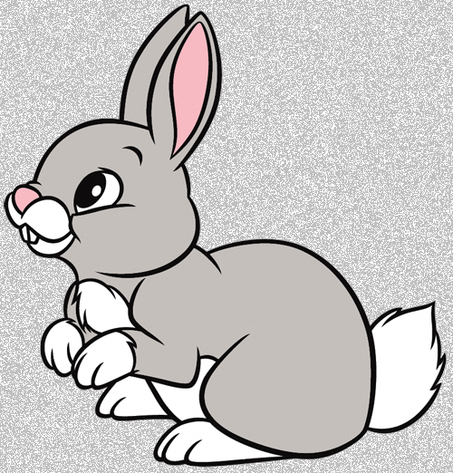 | I want a rabbit.

ES / NH 5 / Unit 3
I want to be a doctor. | I want to be a doctor.

ES / NH 5 / Unit 6
I’d like a hamburger. | I’d like a hamburger.

Find Your Partner Activity Example Cards

Elementary School – 6th Grade

ES / NH 6 / Unit 2
I usually watch TV.  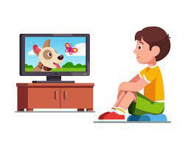 | I usually watch TV.

ES / NH 6 / Unit 6
Where is the beef from?  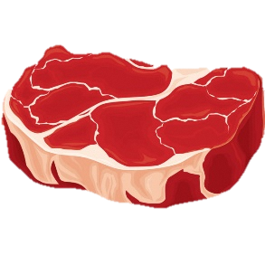 | 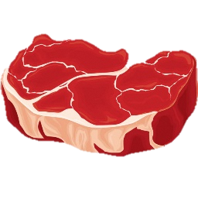  The beef is from Australia.

ES / NH 6 / Unit 7
My best memory is our ~  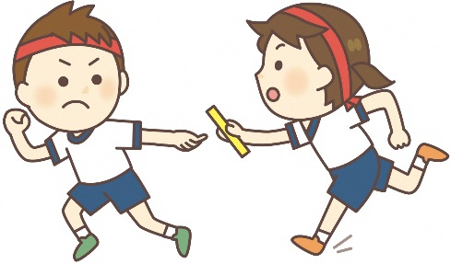 | My best memory is our ~

Find Your Partner Activity Example Cards

Junior High School – 1st Grade

JHS / NH 1 / Unit 2
bacon and eggs  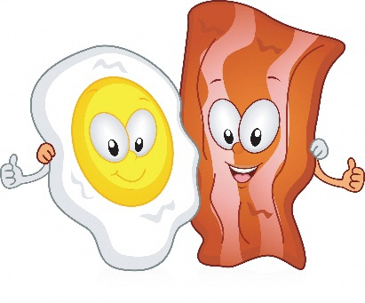 | bacon and eggs

JHS / NH 1 / Unit 8
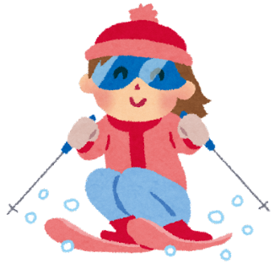  Are you skiing? | I am skiing.

Junior High School – 2nd Grade

JHS / NH 2 / Unit 3
I use this pencil ~ | ~ to write a letter.  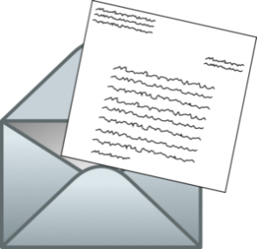

Find Your Partner Activity Example Cards

Junior High School – 3rd Grade

JHS / NH 3 / Unit 1
I have fought a bear.
I have fought a bear.
I have bought a BMW car.
I have bought a BMW car.

